**ShopNest Store Dashboard Report**

.

ShopNest stands as the leading department store in the e-commerce marketplaces in Portugal. Serving as a seamless link, it connects small businesses from various regions in Portugal to channels, streamlining the process with a single point of contact. Through the ShopNest Store, these merchants can showcase and sell their products, with the added convenience of direct shipment to customers facilitated by ShopNest logistics partners. The provided data represents authentic commercial information that has undergone the process of anonymization

1. The Power BI dashboard contains all the charts for the given 8 questions, and it contains all the necessary visualisations, slicers, and data connections for the analysis.
2. In the report document, it explains the dashboard comprehensively and it contains all screenshots or images of the dashboard visuals in the document with a question statement, visualisation, and a clear explanation.

Section with the following details :

1. **Top Categories by Total Price:**
   * Identify and visually represent the top 10 product categories by total sales.

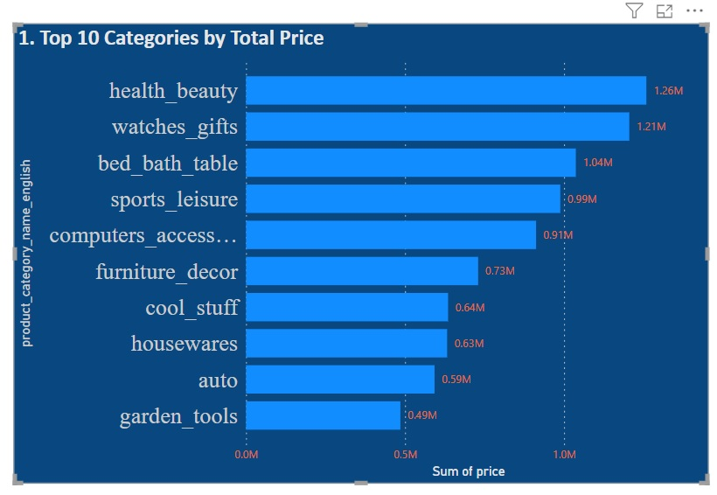

* Above power BI visualization is Top 10 categories by Total Price and health beauty is top 1 product category by total price, price is 1.26 M
* The ShopNest Store maximum price for the product category is Health_beauty.
* The above Power BI visualization shows the top 10 products have the highest prices in the ShopNest store, and they will be mostly purchased by the customers.

1. **Delayed Orders Analysis:**
   * Determine the number of delayed orders in each category. An order is considered delayed if the actual delivery date is later than the estimated delivery date.

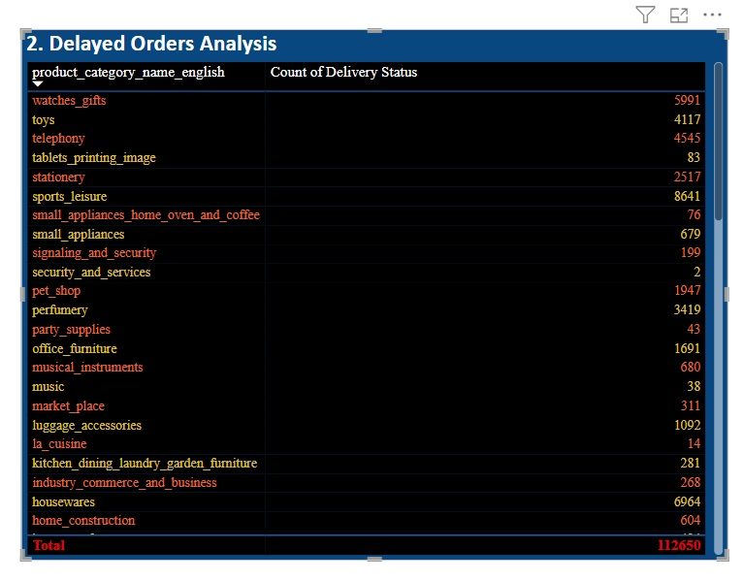

* The above Power BI visualization is Delayed Orders Analysis, and an order is considered delayed if the actual delivery date is later than the estimated delivery date and total count of delayed orders in each category is 112650.
* The highest delayed delivery count in product category is bed_bath_table

1. **Monthly Comparison of Delayed and On-Time Orders:**

Create a dynamic visual that compares the number of delayed orders to the number of orders received earlier for each month.

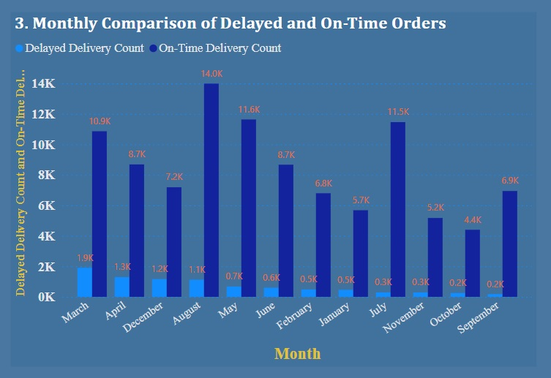

* The above Power BI visualization is a monthly comparison of delayed and on-time orders and the delayed delivery count. March month is high compared to others nearing 2000 delayed deliveries and on-time deliveries. August month is high compared to others, with 14000 on-time deliveries.
* By using the drillthrough cross-report feature to provide a detailed analysis of late and on-time deliveries.

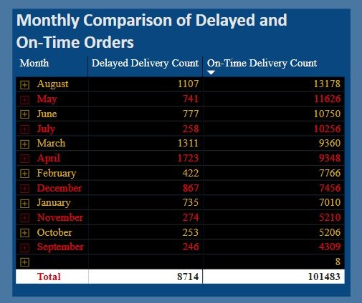

* The above Power BI drill-through visualisation is a monthly comparison of delayed and on-time orders, the delayed delivery count, and the overall delayed delivery count is 8714, and the overall on-time delivery count is 101483.

1. **Payment Method Analysis:**
   * Analyze the most frequently used payment methods by customers using a visually appealing representation, such as a pie chart or other suitable visuals.

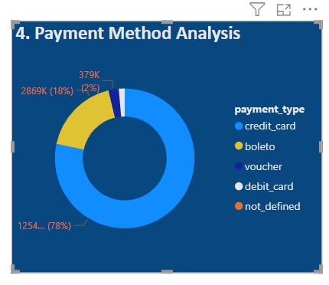

* The above Power BI visualisation is Payment Method Analysis, and credit cards are the frequently used payment methods by customers.

1. **Product Rating Analysis:**

* Determine the top 10 highest-rated products using a bar or column chart.

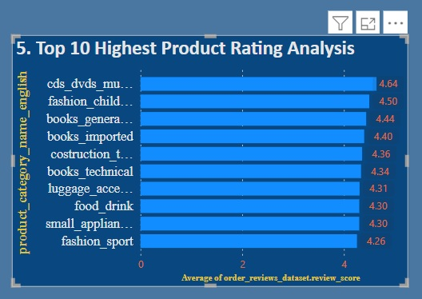

* Above Power BI visualization Product rating analysis determines the top 10 highest-rated products, and by analysis, cds_dvds_musicals got an average top 1 rating and a score of 4.64.
* Determine the bottom 10 lowest-rated products using a bar or column chart

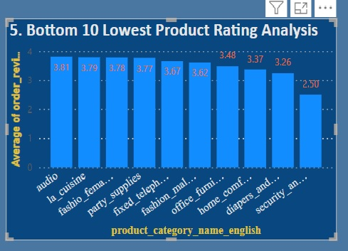

* Above Power BI visualization Product rating analysis determines the bottom 10 lowest-rated products, and by analysis, security_and_services got an average bottom 1 rating (lowest rating) and a score of 2.50.

1. **State-wise Sales Analysis:**
   * Identify and visually represent states with high and low sales, providing a clear understanding of regional sales performance.

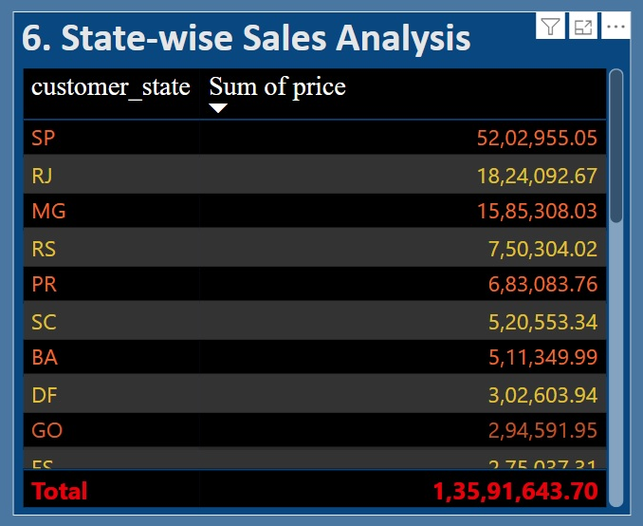

* The above Power BI visualization shows state-wise sales analysis and represents states with high and low sales, providing a clear understanding of regional sales performance.  
  and the highest sale in state wise is SP state, whose price is 52,02,955.05, and the lowest sale in state wise is RR state, whose price is 7,829.43, and the total price of all states is 1,35,91,643.70.

1. **Seasonal Sales Patterns:**
   * Investigate and visualize any seasonal patterns(Quarterly) or trends in sales data over the course of the year.

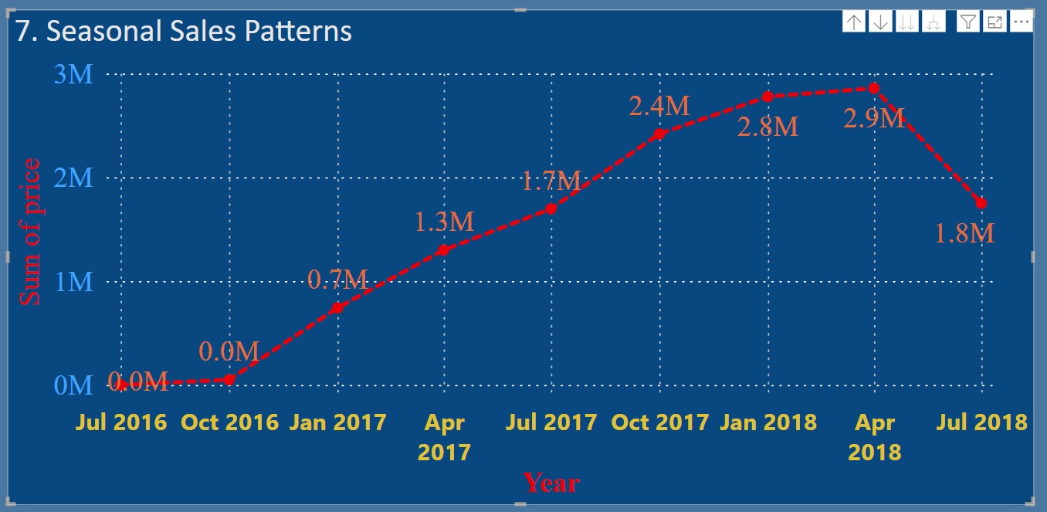

* The above Power BI visualization is the Seasonal Sales Patterns. It visualises any seasonal trends in sales data over the course of the year, and in April 2018, sales were high, and the  price is 2.9 million

1. **Revenue Analysis:**

* Determine the total revenue generated by ShopNest Store  and analysed how it changes over time(Yearly). Represent this information through suitable visuals to highlight trends and patterns.

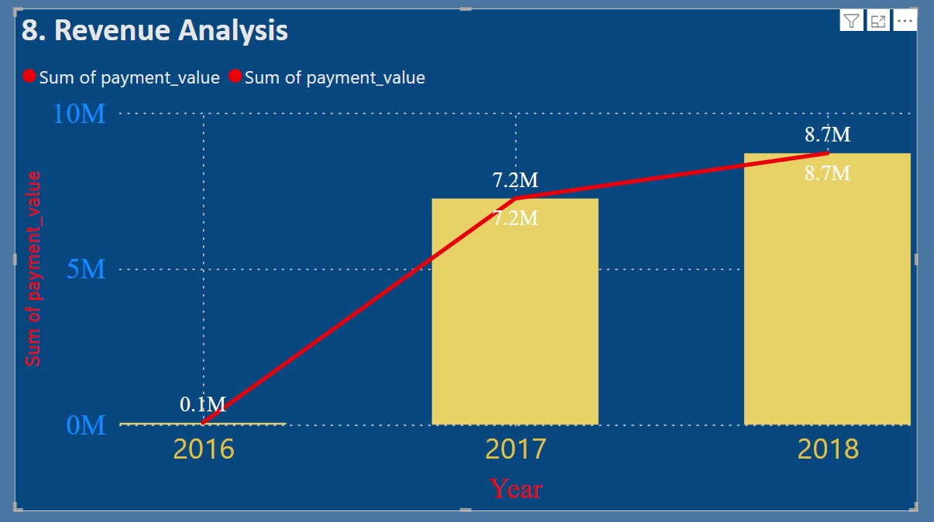

* The above Power BI visualisation is the Revenue Analysis, which determines the total revenue generated by ShopNest Store, and it shows how the visual changes over time (yearly). By analyse through the sum of payment value and year, and it shows the year 2018 got the highest revenue of 8.7 million.